EntreComp

Using EntreComp in #EntEd
‘Entrecomp’ forms part of the QAA (2018) Guidance to Enterprise and Entrepreneurship Education. In this essential guide, EEUK shows how to get the most from this framework.

What is EntreComp?
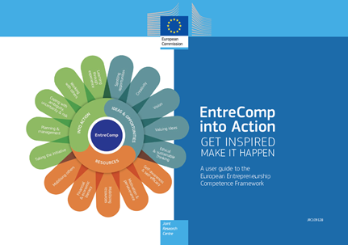
The European Entrepreneurship Competence Framework is a comprehensive, flexible & multi-purpose reference framework designed to help you understand what is meant by enterprise and/or entrepreneurship as a competence. Created by the European Commission, EntreComp identifies the key competences that make up what it means to be entrepreneurial as ‘discovering and acting upon opportunities and ideas, and transforming them into financial, cultural, or social value for others.’
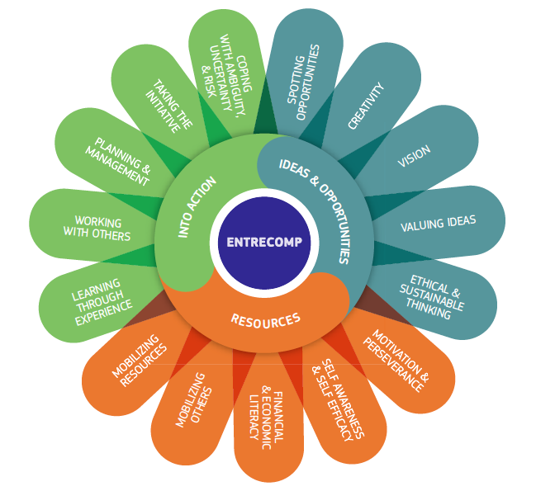
At its very simplest level, it is made up of three areas. These are:
- Ideas and Opportunities,
- Resources, and
- Into Action.

Each of these 3 areas is made up of 5 competences, which together create the 15 building blocks of entrepreneurship as a competence as ‘flower’.

Where do I find EntreComp?
There are two similar EntreComp documents, both designed to help you adapt the framework for your needs.

The most recent documentation can be recognised as it presents the framework as a “flower diagram”. This redesign was published in 2018 as EntreComp into Action and provides a new imagery as a more accessible route into the framework for a wide range of stakeholders.

This guide provides the overview of EntreComp using clearer diagrams to show how the 15 competences relate to each other, suggests routes to accessing the framework and provides a wide range of case examples, tools and ideas on how to use it, as well as providing the detail found in the original report.
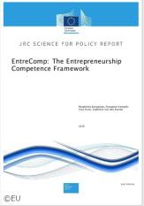
You may also come across the original EntreComp Framework contains the same key text, presenting the approach, rationale, learning outcomes etc with the original imagery as published in 2016.

What are the 15 competences?
The 3 key areas each contain 5 competences to create 15 competences. These are described as broad competences for each of the three areas.

These are presented as:

Ideas and Opportunities

1.1 Spotting opportunities
1.2 Creativity
1.3 Vision
1.4 Valuing ideas
1.5 Ethical & sustainable thinking

Resources

2.1 Self -awareness and self-efficacy
2.2 Motivation and perseverance
2.3 Mobilising Resources
2.4 Financial and Economic Literacy
2.5 Mobilising others

Into Action

3.1 Taking the Initiative
3.2 Planning and Management
3.3 Coping with uncertainty, ambiguity, and risk
3.4 Working with others
3.5 Learning through experience

*NB: There isn’t a “starting point” to EntreComp. EntreComp isn’t linear, so the numbering is not used to suggest an order.

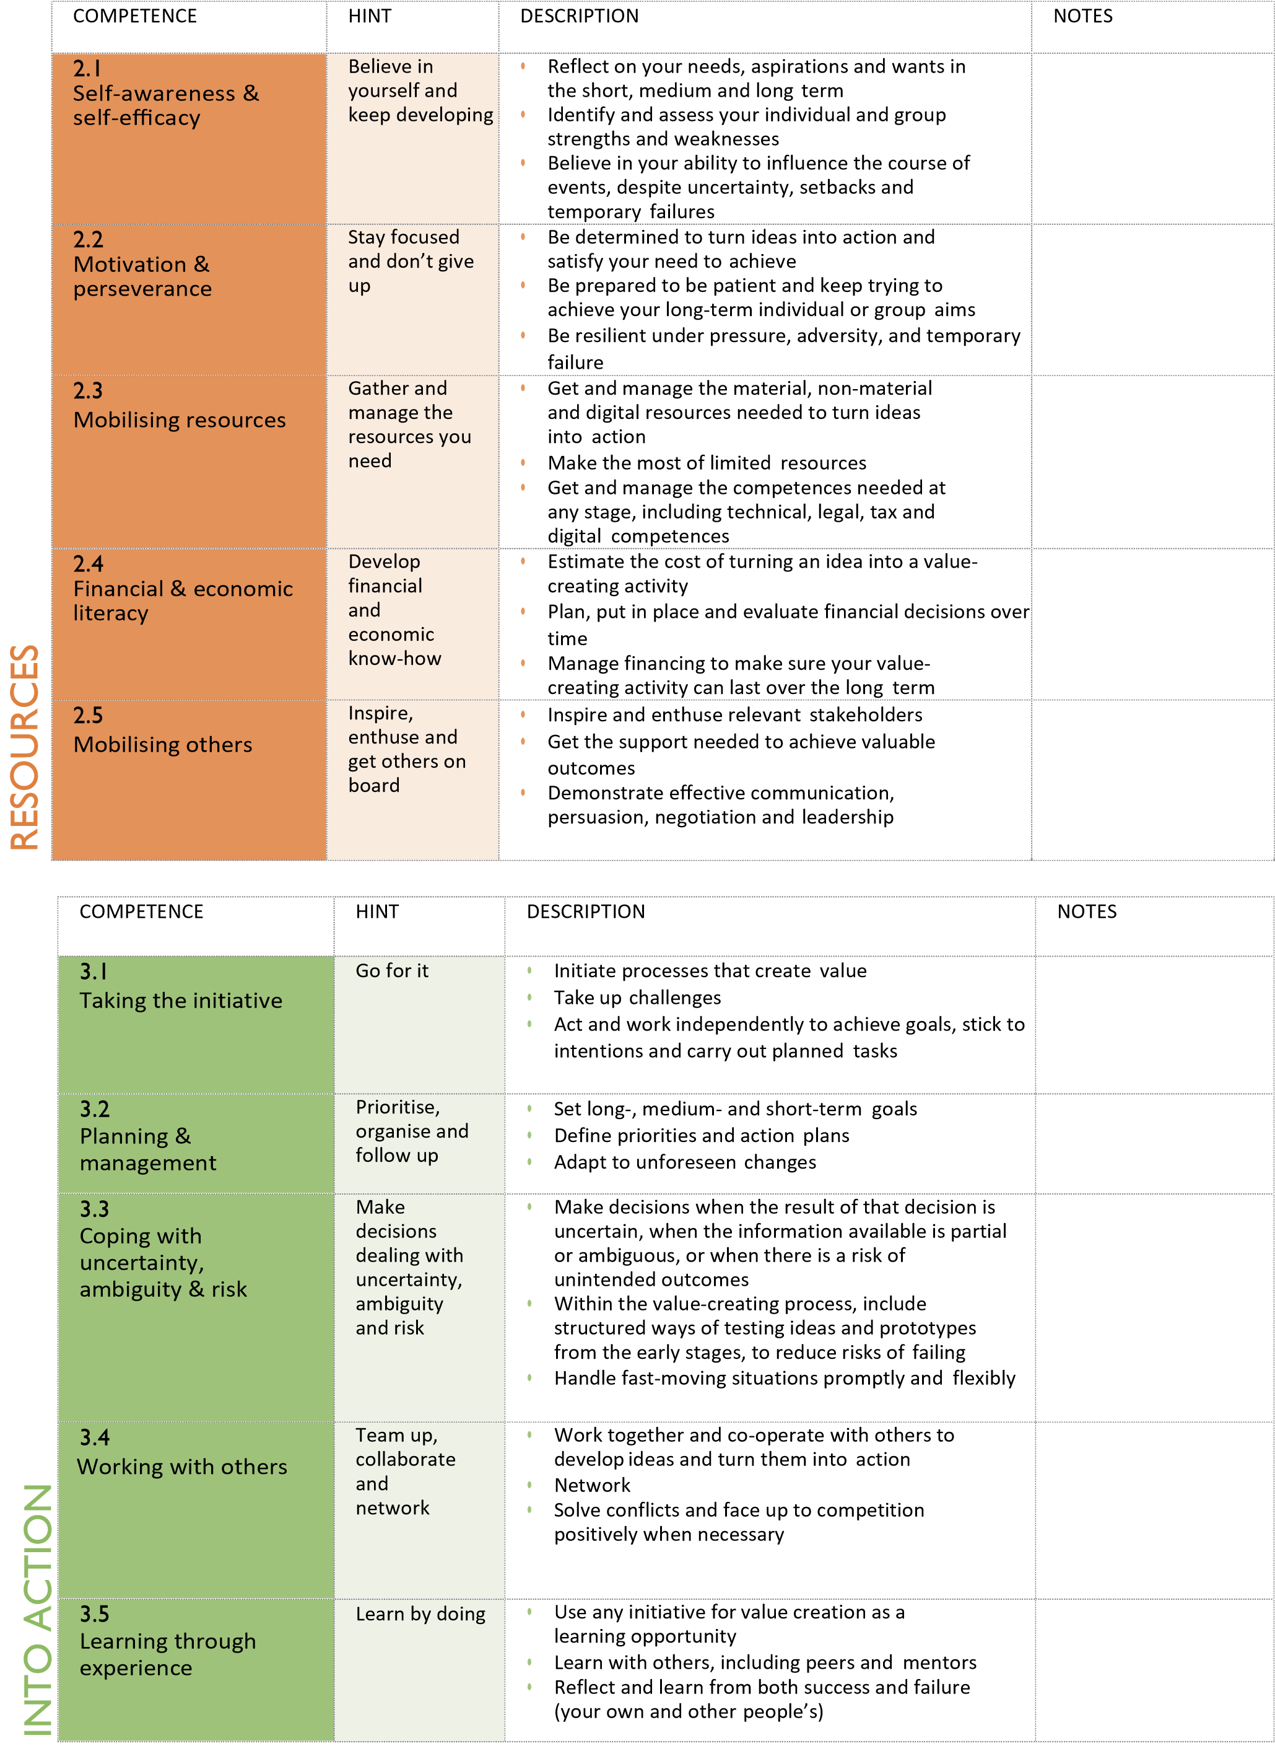
How does 3 become 15 (& then 442)?
The EntreComp framework starts with 3 key areas which deepen into 15 competences. These 15 are presented as the petals of the full ‘flower diagram’ but are actually worked up in more detail within the documentation to show 8 different levels of proficiency (starting with foundation level moving through to ‘expert’). These levels are consistent in their development, as they build from:
- Foundation (as relying on support from others) to
- Intermediate (where independence to work on you own or with others builds) to
- Advanced (in which responsibility is taken, though guidance may support) through to
- Expert (which sees individuals driving transformation, innovation and growth working in complex environments/specific fields).
These competence levels are described as: discover, explore, experiment, dare, improve, reinforce, expand, and transform. Together they create an 8-level progression model (foundation to expert level) which provides 442 learning outcomes.

What could I use EntreComp for?
From the three key areas, through to the 15 competences, and into the 8 progression levels
EntreComp has many uses. The simplicity of the 3 ideas makes it accessible for those who are new to enterprise or becoming aware of the range of competences, whilst the fuller framework provides sufficient detail for curriculum design, assessment (rubrics) and mapping personal development or personal learning journeys. This makes it suitable for mapping, tracking, assessment and research.

How do I know it is robust?
The development of the EntreComp Framework stems from this key report which provides and an overview of existing concepts, policies and initiatives (2015).
What definition underpins EntreComp?
Created by the European Commission, EntreComp uses a Danish definition, which maps into the UK QAA (2018) Guidance as it focusses upon the idea of value. Value creation is the key idea that underpins the EntreComp framework, but value is not defined as ‘profit’. EntreComp takes a much wider approach to entrepreneurship, as it states:
“Entrepreneurship is when you act upon opportunities and ideas and transform them into value for others. The value that is created can be financial, cultural, or social” (FFE-YE, 2012).

How are competences different to skills?
Competencies are the skills, knowledge and behaviours that lead to a successful performance. Competences bring in contextual/situational and subject knowledge to skill use.

How do competence statements help?
The 442 learning outcome statements are written as “I can” competence statements. This is helpful for students looking to build evidence for assessments or job applications/interviews. Competence statement can be crafted as ‘I can’ statements using the CAR method:

Context - Explain the situation; what, where and when. Simply describe the challenge that you faced. Give the reader some background, just enough to set the scene.
Actions - Make sure that you explain how you did something not just what you did. What action or steps did you take? How did you do it? Summarise
Results - What was the outcome? What results did you achieve? Talk about the results. Describe what you have learnt.

Source: CAR or STAR Method (Competences) https://www.gov.uk/guidance/a-brief-guide-to-competencies
How do I explain EntreComp?
Initial support can be found below and an overview of all the Entrecomp reports can be found overleaf.
- Downable fact sheet
- Downable brochure
- Entrecomp Canvas
- Short Entrecomp summary report
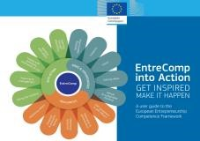
- EntreComp in Action Framework appendix
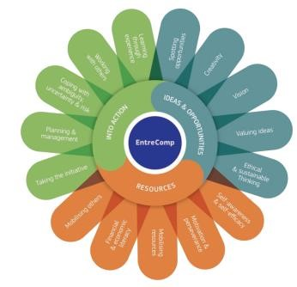

How can I use EntreComp?
The EntreComp framework provides a robust structure for:
- Curriculum mapping
- Curriculum review or design
- Tracking student progress
- Assessment personal development
- Self-Assessment (such as Yoop.fi)
- Research
- Reflective practice
- Assessment rubrics
- Learning journeys
- Enterprise skills
- Business Start-up
- Employees: development
- Appreciating team strengths
- All 3 HEI missions
- Online or in person teaching

The Entrecomp Reports (2016-2020)
This is the original EntreComp Framework report that was published in 2016. It contains all the learning outcomes and detail needed for curriculum design or creating assessment rubrics, outlining the competences across 8 progression levels (from “new to enterprise” to expert).
The more recent EntreComp into Action published in 2018, provides a new imagery and provides an accessible route into the framework for a wide range of stakeholders. The guide provides an easy overview of EntreComp using simple diagrams to show how the competences relate to each other, suggests routes to accessing the framework and provides a wide range of case examples, tools and ideas on how to use it.
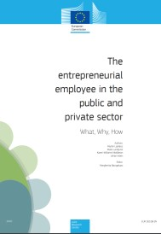
Published in 2020 this report provides an overview of what entrepreneurial employees do, why such behaviours are needed and how any employee can become more entrepreneurial. By linking Entrecomp competences to the workplace it shows how useful the framework can be to those working to create entrepreneurial outcomes in others in all contexts.
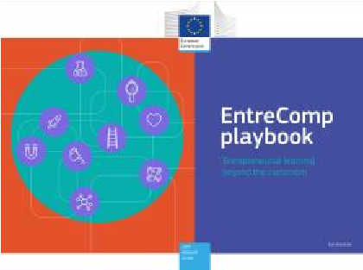
This 2020 companion guide, the Entrecomp playbook, aims to help educators and facilitators design and facilitate entrepreneurial learning activities in meaningful way The playbook sets out nine principles to consider when designing entrepreneurial teaching and learning. It also describes methods that can be adapted to foster entrepreneurial learning and create value for others.
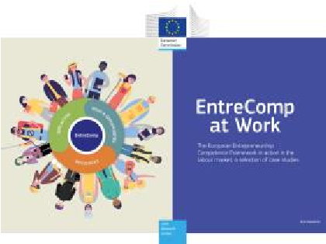
EntreComp at Work focuses on how EntreComp is being used for the provision of services supporting individuals to progress towards and participate in labour market activities or entrepreneurial ventures. Presenting 10 case studies, this report provides insights into actual uses of the EntreComp framework in addressing the entrepreneurial skills challenge to support individuals in their journey towards sustainable employment.
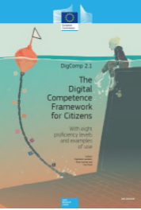
Entrecomp, together with Digcomp form the detail of a wider set of competences applying to all spheres of life that can be acquired through formal informal and non-formal education, and can help citizens to thrive in the 21st Century.

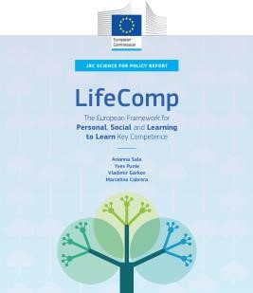
This overarching document Lifecomp provides the umbrella document as it supports the key competence of “ Personal, Social and Learning to Learn” that were set in 2018.
EntreComp References
Bacigalupo, M., Kampylis, P., Punie, Y., & Van den Brande, G. (2016). EntreComp: The
Entrepreneurship Competence Framework. Luxembourg: Publication Office of the European Union

Bacigalupo, M, Weikert Garcia, L; Mansoori, Y; O’Keeffe, W (2020) EntreComp Playbook.:
Entrepreneurial learning beyond the classroom: Publications Office of the European Union
JRC120487 ISBN: 978-92-76-19416-3 (online) ISSN: 1831-9424 (online) EUR 30245 EN
OP KJ-NA-30245-EN-N (online) http://publications.jrc.ec.europa.eu/repository/handle/JRC120487
Caena, F., Developing a European Framework for the Personal, Social and Learning to Learn Key Competence (LifEComp), Punie, Y. editor(s), EUR 29855 EN, Publications Office of the European Union, Luxembourg, 2019, ISBN 978-92-76-11225-9, doi:10.2760/172528, JRC117987.
Carretero Gomez, S., Punie, Y., Vuorikari, R., Cabrera Giraldez, M. and Okeeffe, W., editor(s), Kluzer, S. and Pujol Priego, L., DigComp into Action: Get inspired, make it happen. A user guide to the European Digital Competence Framework, EUR 29115 EN, Publications Office of the European Union, Luxembourg, 2018, ISBN 978-92-79-79901-3, doi:10.2760/112945, JRC110624
Komarkova I, Gagliardi D, Conrads J, Collado A. Entrepreneurship Competence: An Overview of Existing Concepts, Policies and Initiatives - Final Report. Luxembourg (Luxembourg): Publications Office of the European Union; 2015. JRC96531
Lackéus, M., Lundqvist, M., Williams Middleton, K. and Inden, J., The entrepreneurial employee in public and private sector – What, Why, How, Bacigalupo, M. editor(s), EUR 30108 EN, Publications Office of the European Union, Luxembourg, 2020, ISBN 978-92-76-16651-1 (online),978-92-7616652-8 (print), doi:10.2760/460123 (online),10.2760/265489 (print), JRC117661

McCallum, E., Weicht, R., McMullan, L., and Price, A. (2018). EntreComp into Action - Get inspired, make it happen (M. Bacigalupo, & W. O’Keefe Eds.). Luxembourg: Publication Office of the European Union

Mccallum, E., Mcmullan, L., Weicht, R. and Kluzer, S., EntreComp at Work., Bacigalupo, M. editor(s),
EUR 30228 EN, Publications Office of the European Union, Luxembourg, 2020, ISBN 978-92-76-
19002-8 (online), doi:10.2760/673856 (online), JRC120486.

Sala, A., Punie, Y., Garkov, V. and Cabrera Giraldez, M., LifeComp: The European Framework for
Personal, Social and Learning to Learn Key Competence, EUR 30246 EN, Publications Office of the European Union, Luxembourg, 2020, ISBN 978-92-76-19418-7 (online),978-92-76-19417-0 (print), doi:10.2760/302967 (online),10.2760/922681 (print), JRC120911.

EEUK #Entrecomp Alison Price

McCallum, E., Weicht, R., McMullan, L., and Price, A. (2018). EntreComp into Action - Get inspired, make it happen (M. Bacigalupo, & W. O’Keefe Eds.). Luxembourg: Publication Office of the European Union
Bacigalupo, M., Kampylis, P., Punie, Y., & Van den Brande, G. (2016). EntreComp: The Entrepreneurship Competence Framework. Luxembourg: Publication Office of the European Union

